**Assignment -1**

Python Programming

|  |  |
| --- | --- |
| Assignment Date | 19 September 2022 |
| Student Name | Ms. Sindhu S |
| Student Roll Number | 711319CS15 |
| Maximum Marks | 2 Marks |

1.Write a python program to test the given number is prime or not?

Solution:

|  |
| --- |
| def is_prime(num):  count=0 if(num>1): for i in range(1,num+1): if(num%i==0):  count=count+1 if(count==2):  print("Prime") else:  print("Not Prime") num=int(input()) is_prime(num) |

Output:

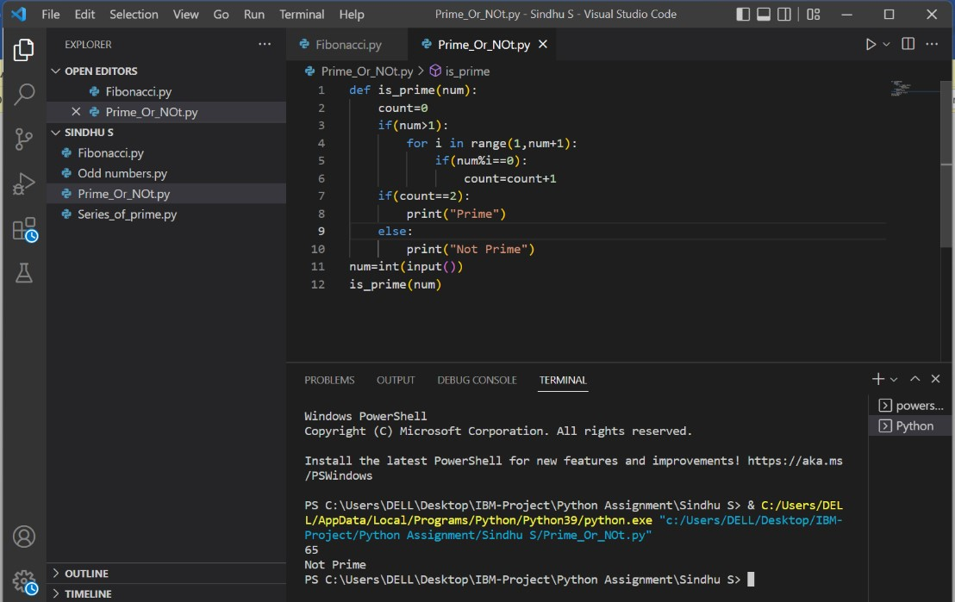

2.Write a program to generate odd numbers from m to n using while loop.

Solution:

m=int(input()) n=int(input()) while(m<=n): if(m%2!=0): print(m)

m=m+1

Output:

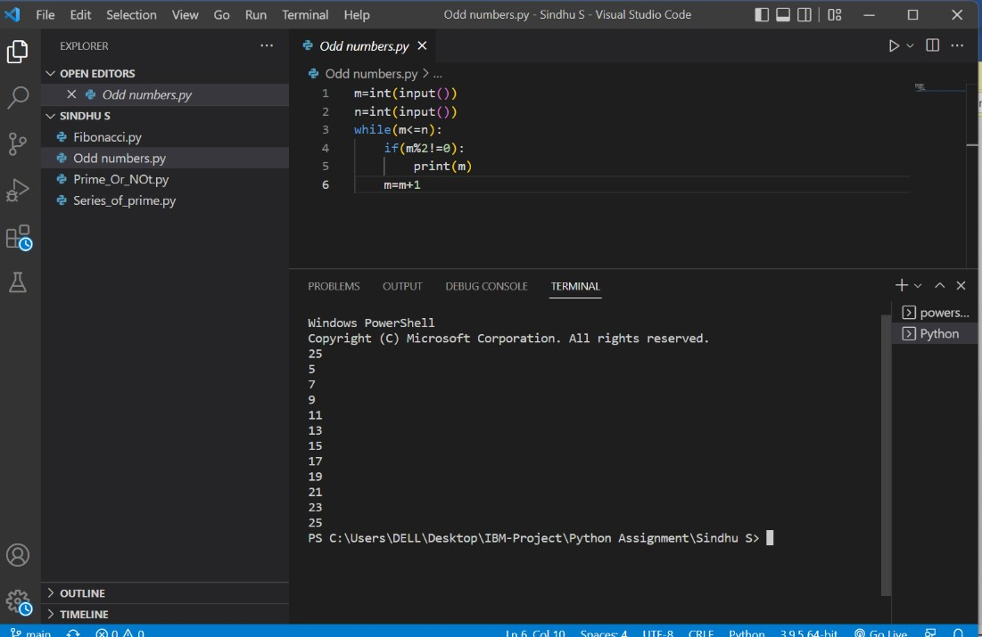

3.Write a program to generate a prime number series upto a given number.

Solution:

|  |
| --- |
| def prime(n):  num=2 while(num<=n): count=0 if(num>1): for i in range(1,num+1): if(num%i==0):  count=count+1 if(count==2): print(num) num=num+1 n=int(input()) prime(n) |

Output:

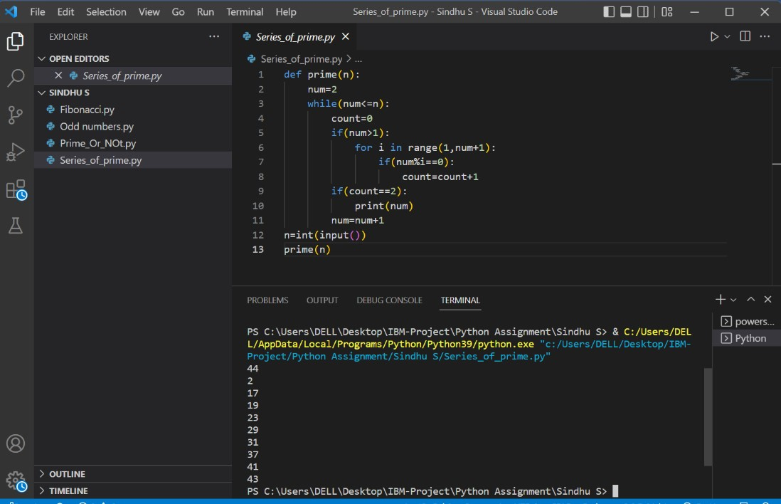

4.Write a python program to generate Fibonacci series.

Solution:

|  |
| --- |
| n=int(input()) n1, n2 = 0, 1 count = 0 if n <= 0:  print("Please enter a positive integer") elif n == 1: print("Fibonacci sequence upto",n,":") print(n1) else:  print("Fibonacci sequence:") while count < n: print(n1) nth = n1 + n2 n1 = n2 n2 = nth count += 1 |

Output:

